# CS 255 System Design Document King

Scott King 6/16/2025

## UML Diagrams

### UML Use Case Diagram

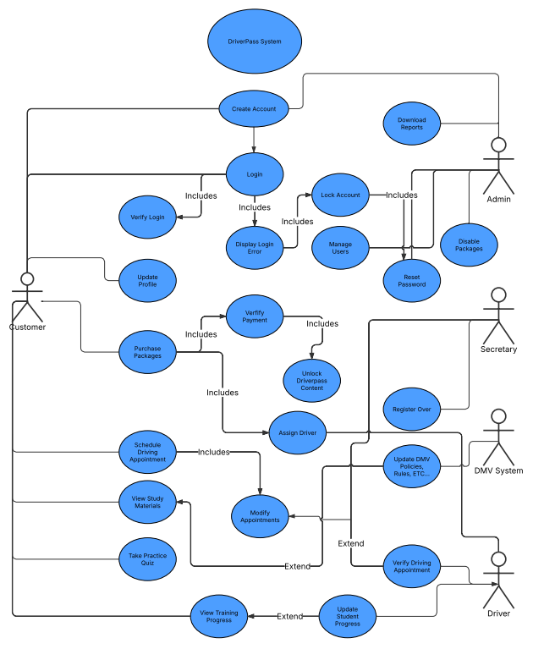

### UML Activity Diagrams

### UML Sequence Diagram

*Schedule Driving Lesson*

### UML Class Diagram

## Technical Requirements

*The DriverPass system requires a secure, scalable, cloud-based infrastructure to support its online scheduling, testing, and user management functionality. Based on the UML diagrams (use case, activity, sequence, and class), the following technical requirements are identified:*

***Hardware Requirements***

* ***Web Servers****: Minimum 2 cloud-hosted web servers (e.g., AWS EC2 or Azure VMs) for handling front-end traffic.*
* ***Database Server****: Cloud-hosted relational database instance (e.g., AWS RDS, MySQL/Azure SQL) with redundancy enabled.*
* ***Backup Storage****: Cloud storage for daily automated backups (e.g., Amazon S3 or Azure Blob Storage).*

***Software Requirements***

* ***Web Application Framework****: A modern MVC-based framework such as Django (Python), Node.js/Express (JavaScript), or ASP.NET Core (C#) to manage business logic and serve front-end content.*
* ***Database Management System****: MySQL or PostgreSQL for relational database operations supporting classes such as Student, Appointment, Lesson, and PracticeTest.*
* ***Authentication & Role Management****: Integration of an identity provider (e.g., Auth0, Firebase Auth, or custom RBAC middleware) for secure login, password reset, and role-based access control.*
* ***Browser Compatibility****: Fully compatible with Chrome, Firefox, Safari, and Edge.*

***Tools***

* ***Lucidchart****: For creating and managing UML diagrams and visual models.*
* ***GitHub or GitLab****: For version control and collaboration.*
* ***CI/CD Pipeline****: Use tools like GitHub Actions, Jenkins, or Azure DevOps for automated testing, integration, and deployment.*

***Infrastructure Requirements***

* ***Cloud Hosting****: Deployed on a reliable cloud platform such as AWS, Azure, or Google Cloud for high availability and global accessibility.*
* ***TLS Encryption****: All traffic must be encrypted using TLS 1.2 or higher to protect user data.*
* ***DMV Integration API****: A secure REST API integration to receive DMV policy updates and test content dynamically.*
* ***Logging and Monitoring****: Use tools like AWS CloudWatch, Datadog, or Splunk for real-time error tracking, auditing activity logs, and system performance monitoring.*
* ***Scalability****: Auto-scaling infrastructure to handle spikes in user activity during peak sign-up or testing periods.*